November UpdaTED 2015
Dear Group Chair,

Happy National Non Fiction November
Do let me know the details of your events so I can pass them onto to the newsletter/website/blog.
Please pass this newsletter on to all your members and encourage them to think about joining the Exec.
You will receive in the next mailing the paper newsletter invoices for this year 2015 where appropriate,

Executive vacancies 2016-2018
Would you like to join us ?
We are looking for Federation members to join the Executive committee and have vacancies in the following areas. We meet 4 times per year on a Saturday in London near Waterloo and much of our interim work is done via email and phone. You would be a member of a book group and be formally elected at our AGM for two years.
You can claim travelling expenses.

Treasurer
Responsibilities include
-receiving all money, issue receipts, pay bills & expenses & keep accounts relating to the Federation, in a form suitable for the auditors
-maintaining all bank accounts directly related to the Federation.
-presenting annual accounts to each Annual General Meeting, in line with the Federation’s Constitution and preparing accounts analysis for the Executive Committee, in a written report to each member before each Executive committee meeting.
-preparing a budget for the Executive Committee, as requested by the Executive Committee and assist in making a case for grants with the authority of the Executive Committee.
-acting as a signatory for cheques along with 3 other Executive Committee members.
-ensuring as far as is practically possible, that the financial management of the affiliated Book Groups meets Charity Commission guidelines & requirements.
-organising the nationwide insurance cover, together with any additional cover for individual Book Groups that request it, & to negotiate with the Insurance Brokers on behalf of the Federation.

It is not a very time consuming or difficult job, but does require a understanding of accounts and an eye for details. If you have kept your book group accounts or have experiences of finances in an office setting then you would find this straightforward.
If you would like to find out more, please email Jane and Julia (who currently do this job) on info@fcbg.org.uk
for more detailed information.
National Non fiction November
Responsibilities include
-coordinating all deadline dates for NNFN publicity & activities and be involved with the printing & distribution of all NNFN publicity material.
- ensuring Launch continuity & support the Book Group organising the Launch.
- being responsible for liaising with all Book Groups wishing to be involved with NNFN and all outside organisations wishing to be involved with NNFN
- liaising with the Chair, and the sponsor to ensure continuity of sponsorship.

Zoe says “It is not a time consuming or difficult job, but does require imagination, energy and enthusiasm. “
If you would like to find out more, please email Zoe (who currently does this job) on zoe.toft@kuvik.net for more detailed information.

The FCBG website
Melanie McGilloway and Zoe Toft are stepping down from Executive and so we are urgently seeking one (or two) volunteers to take over maintenance of the FCBG website. The job could be done by two people, each taking responsibility for one of the aspects outlined below or by one.
1. Back-end maintenance (about an hour a month)
This is the more technical part of the job and requires a little bit of IT knowledge.
Responsibilities include
-renewing hosting and domain name registration
-managing the database which supports the website ie keeping an eye on traffic, setting up email addresses, keeping Wordpress up to date and customising where required
-dealing with our hosts when problems arise (eg if the server goes down or there are problems with email)
Ideal skills
-familiarity with web administration eg Plesk
-knowledge of Wordpress
It is not a time consuming or difficult job, but does require a little bit of IT skills.
If you would like to find out more, please email Zoe (who currently does this job) on zoe.toft@kuvik.net for more detailed information.
2. Keeping website content up-to-date
This 'is not a time-consuming job but might require more input at peak times for the Federation (ie National Share A Story Month, Children's Book Award, National Non-Fiction November). So generally up to an hour a month (but usually less than that), with maybe a couple of hours a month at those peak times.
Responsibilities include
- updating information on the website as and when requested by book groups and members of the executive
- checking information is up to date (liaising with the National Secretary regarding book groups contacts, and members of the executive in charge of specific events for example)
Ideal skills
- knowledge of Wordpress or another blog/website platform. However no technical knowledge is need for this post. Anyone with a good grasp of desktop publishing will already hold the right skills to 'operate' Wordpress.
If you would like to find out more, please email Mélanie (who currently does this job) on librarymice@gmail.com for more detailed information.
Newsletter Invoices for 2016
Please could you confirm the number of copies your book group requires by JANUARY 1ST 2016 by emailing me on info@fcbg.org.uk. You will receive your 2016 newsletter invoice in the mailing before Conference .

The Children’s Book Award

Here is the Top Ten children’s books as voted for by children. The ceremony will take place in London in May 2016. More details to follow.

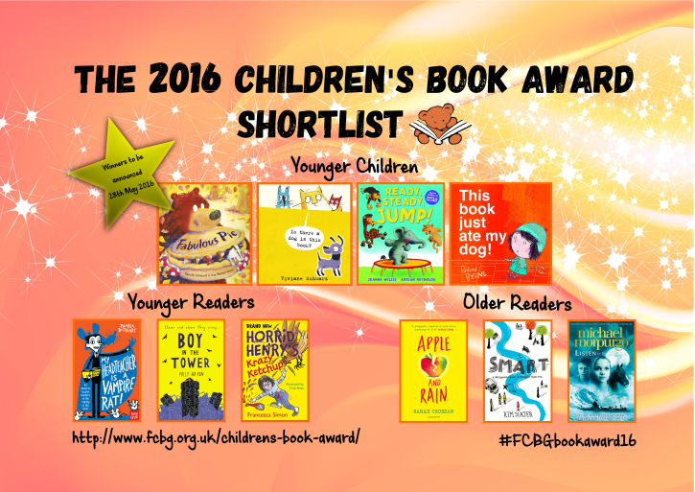

National Share A Story Month 2016
Louise Stothard and Chris Routh write:
"We are putting together ideas for NSSM 2016 which will be in May as usual. The theme is “A Place for Stories’ and we are encouraging (safe) storytelling on buses, trains, street corners, cafes, a supermarket, castle, ice rink, museums, school playing fields, Zoos, anywhere – the opportunities are endless!
We shall ask for photos of youngsters reading in unusual (and safe) places – in a tree, behind the sofa, in a tent, on the plane, a train, the beach, in a caravan, in a canoe, under the bed etc etc (with parent permission of course!) We’d love to know what ideas you come up with.
We would like to make a list of stories based in unusual places such as The Children who lived in a Barn by Eleanor Graham, Whistling Jack by Linda Newbery (canal), I Capture the Castle, Dodie Smith, Walk Two Moons, by Sharon Creech (road trip) so any further ideas are welcome!
More information will be forthcoming over the next few months. Contact Louise and Chris on info@fcbg.org.uk.

Conference 2016
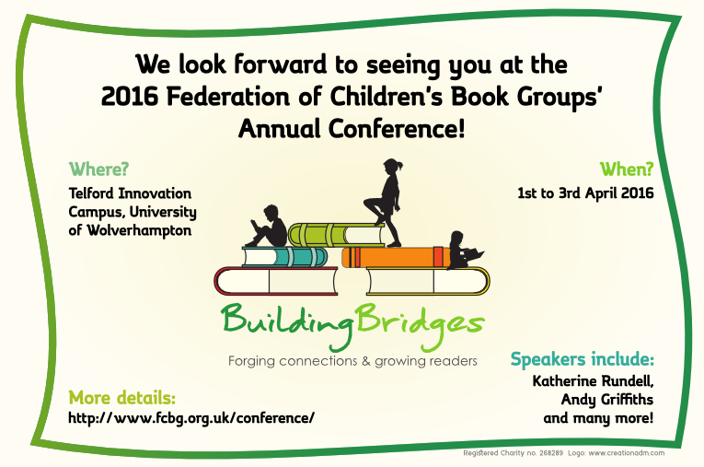

I am really looking forward to our next Conference and Ros is working her usual magic combining well known faces with new authors and illustrators to make a stimulating programme. Full details will be on the website www.fcbg.org.uk

I will be sending out all the accompanying admin as usual but would like to invite you now for items to go on the agenda for the book group meeting. This is an ideal opportunity to discuss problems and their possible solutions as well as share good practices.
Please email Karen Hellewell on info@fcbg.org.uk

Jane Etheridge writes
“All the rooms are en suite but the standard single rooms have a slightly larger bed and a TV. There are no twin rooms this year.
We can include your twitter handles and blogs on your name badges if you wish, which is why it is on the booking form.
If any book groups would like to apply for a bursary for one of their members to attend Conference they can contact Jane Etheridge at fcbgconference@gmail.com to get an application form."

Please let me know if your group would be keen to host future Conferences in 2017 /2018. We pride ourselves on the smooth running of our Conferences and the effective and efficient way in which book group members pull together is a major feature commented upon by delegates
I would also welcome any ideas/suggestions to celebrate our 50th birthday in terms of activities, venues, and displays. Contact me on info@fcbg.org.uk.

WICKED announces sixth year of WICKED YOUNG WRITER AWARDS

WICKED, the award-winning classic musical that tells the incredible untold story of the witches of Oz, is proud to announce the sixth year of the prestigious WICKED YOUNG WRITER AWARDS, which this year introduces a new non-fiction category. Entries open 3 November 2015 and close 11 March 2016. Details can be found at www.WickedYoungWriters.com.
Wicked is also delighted to announce that Her Royal Highness The Duchess of Cornwall has agreed to extend her patronage for a further five years.
As in previous years, entrants can enter one of five different age categories; 5-7, 8-10, 11-14, 15-17, 18-25. In addition, the 2016 awards scheme marks the launch of the FOR GOOD Award for Non-Fiction, encouraging 15-25 year olds to write essays or articles that recognise the positive impact that people can have on each other, their communities and the world we live in. The new category celebrates the WICKED: FOR GOOD programme, which supports the charitable causes at the heart of the stage musical.
The Awards were created by the producers of Wicked in 2010, in collaboration with the National Literacy Trust and spearheaded by bestselling author Michael Morpurgo, to recognise excellence in writing, encourage creativity and develop writing talent in young people. Since launching, over 20,000 young people, aged between 5 and 25, have entered original and thought-provoking pieces of writing that consistently reflect the interests, concerns and deepest thoughts of young people, providing a first-look at the emerging voices of a new generation.
A shortlist of 120 entrants from across the UK will see their work published in the WICKED YOUNG WRITER AWARDS Anthology. They are also invited to an exclusive ceremony at London’s Apollo Victoria, home to the hit musical since 2006, where judges and members of the Wicked cast will announce who has won in each category.
Pieces of original writing can be submitted, either individually or as part of a school group, until 11 March 2016. The overall winners from each category will win a VIP family experience to the West End production of Wicked, including an exclusive backstage tour and cast meet-and-greet, £50 book/eBook tokens, plus £100 worth of books for their school library donated by Hachette Children’s Books. The individual school with the highest number of entries will receive a bespoke writing workshop at their respective school.

The WICKED YOUNG WRITER AWARDS are separated into six categories, for entrants between the ages of 5-25. They allow young people from across the UK and Ireland to enter a piece of writing on a theme or subject of their choice. Young people are free to submit entries written at home or at school, and teachers are encouraged to enter writing on behalf of their pupils. Exclusive teachers’ resources can be found online including tips for inspiring and encouraging writing in the classroom.
The final date for entries is 11 March 2016. Schools and individuals can download entry forms and find tips and videos about the award at www.WickedYoungWriters.com
Further information can be found at www.WickedForGood.co.uk
World Book Day 2016

It's all go here at World Book Day as more and more schools sign up to World Book Day 2016 which is happening on Thursday 3rd March. If you're a nursery or secondary school and haven't registered yet, time is running out so click here NOW and register before Friday the 27th of November!
We're also thrilled that our most splendiferous World Book Day Award (or WoBoD for short) is well underway.
Simply tell us 'where reading takes you' in the most creative way possible and your school could win £10,000 worth of books AND a £10,000 library makeover!
Entries are rolling in thick and fast and we would love to hear from your school too. DON'T FORGET the closing date is the 1st of December! Click here for the lowdown...
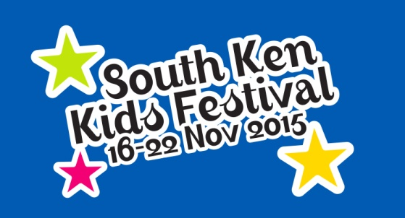
The South Ken Kids Festival will take place at the Institut français in London from the 16-22 November. Our week-long children’s literature festival offers a fun-packed programme for families and schools and features some of the greatest writers and illustrators from the UK, France and abroad.
Quentin Blake (the festival’s patron), Tony Ross, Claude Ponti and Axel Scheffler are some of the names who will take part in our wide range of events including workshops, films, live drawing, and more!

