Contents:
- Executive Summary: p 2 - 4
- Original aims and context: p 5
- The project: p 6 - 11
- Evaluation and feedback from children, adults, groups, Anna Conomos: p 12 - 22
- Legacy and conclusions: p 23

Acknowledgements
The Federation of Children’s Book Groups would like to thank the Ragdoll Foundation for funding the project and Anna Conomos, the Jean Russell Storyteller, for her whole-hearted engagement with the ethos of the project and the Federation.
The Project Co-ordinator and national Executive would like to thank all the participating groups for their enthusiasm, hard work and commitment to the project, to the planning and organisation needed for each event and for their support throughout.
We would also like to thank all the participating schools, community stakeholders, Headteachers, teaching and support staff, the staff at the hospital and special school in Swindon and other partners in the project including the video company.
Finally, we would like to thank the children and young people across the country who embraced performance storytelling and participated in the project with such gusto, courage and brio.
It has been an absolute joy to have been part of this project.

Julia Miller
National Co-ordinator
Jean Russell Storytelling Project
April 2017

1. Executive Summary
- Numbers involved
No. of children and young people (aged 2 – 14): 1,800
No. of teachers and parents in 2 workshops: 80
No. of teacher training students: 19
No. of schools: 19
- Summary of evaluations
No. of feedback forms received from the schools and the children: 205
No. enjoyed the sessions: 202 i.e. 99% positive response
Key themes from evaluations:
- Anna’s enthusiasm, ability to engage all the children and storytelling expertise
- Enjoyment in participating in the acting and story-making
- Enjoyment in listening to the stories and seeing them being enacted
- Fun
- The project would have been even better if the sessions had been longer, if there could have been time for another story and if children could have been involved in the parents’ workshop.
No. of responses received from the groups: 10
Event rating: 100% excellent
Event organisation: 100% Satisfactory and above
Key themes:
- Anna’s engagement and ability to adapt to differing abilities
- Improvement in local relationships with schools, teachers and local partners as a result
- Engagement of the children and their participation
- The project would have been even better if a photographer could have been hired for every event, if some of the teachers had been more engaged and if Anna had told a complete story.

- The legacy
- Participating groups: Each participating group has identified a number of actions to continue the project (detailed in the report).
North Somerset: Continued running storytelling sessions across year groups and schools, supported by the techniques demonstrated by Anna during her twilight INSET session.
Aldbourne: The Nursery school is to develop storytelling using props; the primary school is to continue creating stories with alternative endings, using more pupil participation and songs.
Reading: The participating school joined the group and is now participating in the Children’s Book Award; the project has galvanised the group to continue to develop work with the wider community.
Birmingham: The teachers are to use some of Anna’s storytelling techniques in class; the schools involved immediately joined the group. The national Executive has proposals to build on the project in Birmingham as part of the Federation’s 50th year (see Legacy and Conclusions).
Ipswich: The group intends to hold more similar events for young carers, with a focus on enjoyment and developing imagination.
Oxford: The group plan to sustain the storytelling ethos with local schools and during local conferences, working with the Education department of Oxford Brookes and the Story Museum. Anna herself has been collaborating with the Story Museum as a result of the project.
In addition:
- Each participating school received a complimentary copy of Anna’s Teacher Training DVD and many copies of free books, stickers, posters and bookmarks as gifts for the children. Those Nursery schools who had a visit from Anna received a complimentary copy of the book and CD with Anna’s story that she had performed with the children: Clara the Rhinoceros Who Wanted to be a Film Star.
- Other Federation groups: Each group was provided with a copy of Anna’s training DVD for teachers and parents and encouraged to embed storytelling techniques within the Federation at grassroots level. This proposal is to be developed further at a national level as part of the 50th birthday theme.
- Online video: The video of the final event at Oxford has been put on YouTube and offers a snapshot of elements of the performance with interviews with teachers, children and members of the Federation. This interviews with the teachers provide examples of the benefits of storytelling for the curriculum, demonstrating the value of the project and storyteller for children and in schools. The full performance is available in the Federation archive.
- The stories: The story scripts created by Anna for performance at the Reading Whitley Community Festival have been donated to the Reading group for future use within the community and the school are also held in the Federation archive.

- Conclusions and lessons learned
- The choice of storyteller was vital to the success of the project. Anna Conomos proved to be an inspirational choice due to her dynamic energy, her intelligent and sensitive approach to the project and her passion for storytelling across cultures and across generations.
- The most unexpected success was the positive experience of the parents (particularly the fathers) in the parents’ workshop in Birmingham. Their comments are provided in the Evaluation and feedback section of this report. We would like to build on this as part of our 50th birthday project.
- Anna’s thoughtful selection of the children who were to be the main actors during the sessions, often confounded teachers’ expectations of their abilities to focus, learn and perform. Improvements in some of the children’s confidence and self-esteem could even be observed as the performances and sessions progressed. Teachers after the event expressed surprise how those children who they described as ‘shy’, or ‘hyper-active’ performed above expectation. The project showed that it is not always the extroverted child who responds to and learns most from involvement in performance storytelling. In Reading it was the ‘quiet and shy’ children who stepped up to the microphone by the end of the day, brimming with confidence and enjoyment.
- Relationships between the groups and the participating schools and community groups were critical for engagement with the project and for the smooth running of the events. In those events were there was involvement with multiple principals there were occasionally issues of communication, which decreased understanding of the project and therefore subsequent engagement in the ethos as well as the logistics of the project. Engagement would probably have been improved if the groups or National Coordinator could have met all the teachers involved first but available time in schools precluded this. The project was particularly successful in groups who managed to have personal conversations with the teachers involved prior to their event. One of the key contacts left her role two months prior to the event which reduced the event’s influence within the community group.

2. Original aims and context
Original aims
The project was founded on and measured by the values of the Federation: integrity, inclusivity and outreach, a passion for making a difference and a child-centred ethos. It was designed to leverage the uniqueness of the Federation – its network of grass-roots, its community-based groups, its focus on bringing young people and stories together and its national reach.
We hoped that the project will lead to a number of legacies:
- For the participating young people, not only immediate enjoyment of the stories themselves, but an enduring sense of the value that stories bring and an enhanced understanding of themselves and of others.
- For the groups, the development of new and lasting partnerships within their communities and therefore growth in the membership of the groups themselves.
- For the Federation, a wider appreciation of the work that we do, possibly linked to the creation of an on-line compilation of some of the stories and experiences of the young people that could be collated throughout the project.
Storytelling: The value of stories and performance storytelling
Federation events, both local and national, have always had stories and storytelling at their heart. Jean Russell believed in fostering the imaginative development of children and understood what stories mean to children who are in pain and distress, helping them to have fun and to share joy.
In the hands of the right storyteller, stories will support young people in understanding their lives and themselves, helping them explore their own cultural roots, their experiences and their sense of identity. Stories offer insights, revealing universal truths; listening to stories promotes an immediate sense of wellbeing and relaxation within the child.
A story well told encourages active listening as well as participation, thereby developing young people’s communication and empathetic skills, their imagination and creativity and their cooperative skills. Stories are a powerful way of helping children to discover their imagination, to experience joy in play and to gain confidence in expressing themselves through their performance.
As described by the teachers in Oxford, storytelling improves vocabulary, particularly for children who struggle with reading and helps with understanding sentence construction. Participating in storytelling aids children with story sequencing and gives them the confidence to use their imagination to invent their own stories.
Performance storytelling is an immersive experience using props, music and song, call and response and participatory actions to enhance the storytelling experience. Anna Conomos was awarded Young Storyteller of the Year in 2005 and her performance storytelling across cultures and generations was considered by the national Executive to be the most appropriate for the project. Anna was selected from a short list of 3 storytellers, through a process of interview and online performance, as the result of consensus reached at the Executive. She showed herself to be the right choice.

- The Project
Every children’s book group was invited to bid to participate in the Jean Russell Storytelling Project. The groups were challenged to find out about the deprived areas of their community and to be innovative about developing potential collaborative partnerships. Each bid was asked to reflect the values of the Federation and make a difference to the local community by targeting the under-privileged or vulnerable young people.
Eight book groups from a total of 25 applied to be involved and six groups were chosen:
North Somerset (Weston-super-Mare); Aldbourne (Swindon); Reading; Birmingham; Ipswich and Oxford.
A brief summary of each group’s project is given below.
North Somerset
‘What makes a story interesting is how you tell it…use your face/body/hands...look at your audience...be confident...have fun…enjoy it’
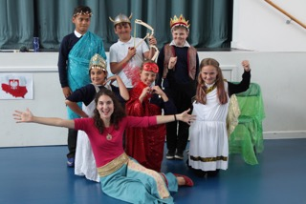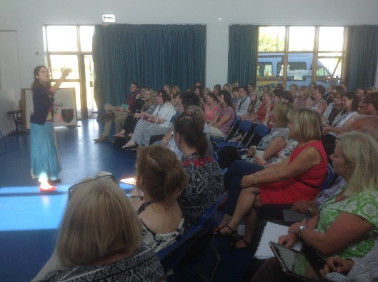
The project worked with five schools in a Cooperative Education Trust, situated on the deprived Bournville Estate, with the highest levels of child poverty in the South West. The proportion of pupils eligible for the pupil premium is well above the national average; at one school 25% of its pupils have Special Educational Needs. The level of skills at entry level of Nursery pupils is very low.
The aim was for children to be inspired, learning skills to tell stories to each other, their families, the community…not only re-tellings but also new stories that they made up themselves. To facilitate this, after each storytelling session, Anna asked the children how they would imagine the story continuing and suggested that they write, draw, create and tell these story continuations.
15 – 20 children from each year group were selected to participate from each of the five Trust schools. Ages were mixed from Years 1 up to Year 6. Anna performed traditional tales to develop the children’s appreciation of other cultures; each session was adapted to the relevant age group. Anna dressed in costumes appropriate to the tale and used percussion and costume props with the children. Every story had a moral, which Anna brought out during the storytelling and in discussion before and afterwards.
The number of children involved directly with the Jean Russell Storyteller was 220.
A twilight INSET storytelling session was also held with 70 teachers from the Trust, working on storytelling techniques that can be used throughout the curriculum.
Aldbourne (Swindon)
‘A wonderful experience.’ ‘Really fun…almost the best day’
‘Very enjoyable, fun, educational, involved all the children’

Anna spent a day at the Children’s Unit at the Great Western Hospital in Swindon, working with the Education Other Than At School department (EOTAS). In the morning, Anna told the story of Jason and the Argonauts to 14 children and young people from Uplands Special School and children from the Children Unit at the hospital. Anna involved all the children in her performance storytelling, encouraging them to use props and costumes which she had chosen for their sensory properties.
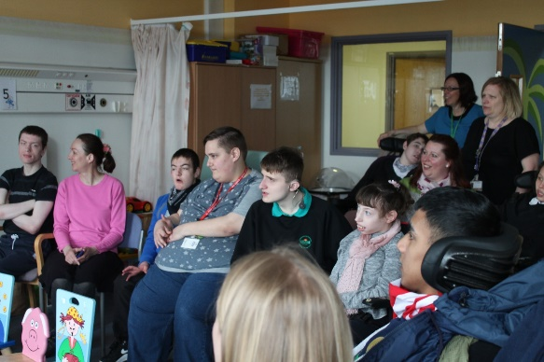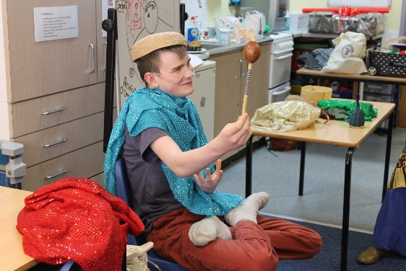
In the afternoon, Anna worked with five older young people in the hospital’s EOTAS department. The young people explored with Anna how to create tableaux to build the scenes together before ending with a song. This use of ‘freeze-framing’ is a key element of Anna’s technique.
The second day was held at Robert Le Kyng Primary School, which has an above average proportion of children with special educational needs. It is one of the designated schools in Wiltshire for children with multiple learning difficulties and disabilities, including cerebral palsy and spastic diplegia. Pupil turnover is higher than average. The school is in an area of deprivation with 20% of the children having free school meals and the percentage of children with a statement or on Action Plus is above the national average.
Anna performed the Greek myth of Daedalus, Theseus and the Minotaur, celebrating the creative engineering genius of Isambard Kingdom Brunel and his role in developing Swindon as a railway engineering town, who she linked to the creative engineering genius of Daedalus. The Head was delighted that the themes chosen by Anna also linked to the school’s NED programme.
In the afternoon, Anna worked with the Nursery School, transporting the children to India, where Clara the Rhinoceros dreams of becoming an international film star. However, she has to learn to appreciate the value of friendship and to accept herself as she truly is, all with the help of the jungle animals as vocalised by the audience.
The number of children involved directly was 20 + 420, of which 7 were in wheelchairs, + 20 (reduced due to an outbreak of chicken pox) from the Nursery School.
Reading
Reading worked in Whitley, the most deprived area of Reading, with the charitable trust Aspire2, having previously worked with them on other projects in local schools. Aspire2 was set up to foster a sense of community. It holds an annual WhitFest Community Festival to encourage local families, schools and organisations to identify more strongly with their local community.
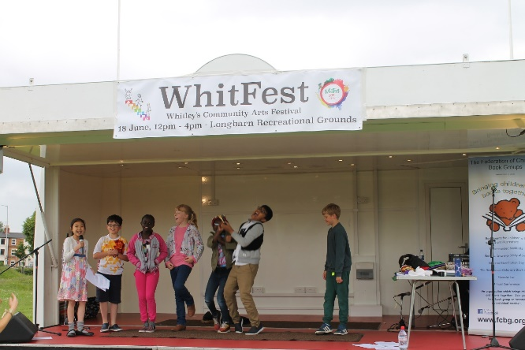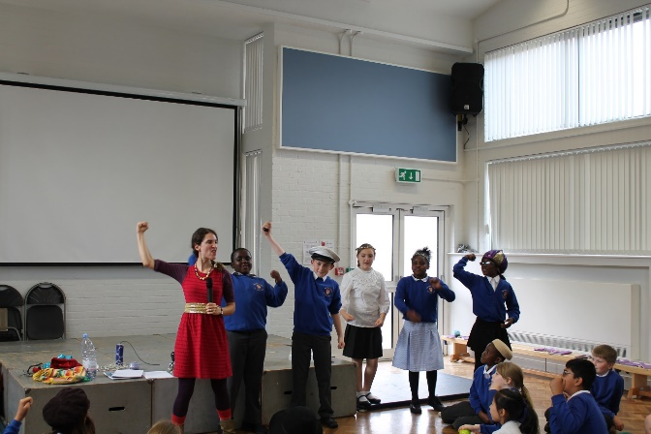
New Christ Church School was invited to participate in the project by Aspire2 as it is a local school which had not engaged in many community-based activities and whose parents were not involved in the community. The project therefore had three principals: Reading CBG; Aspire2; the school.
The school had recently appointed a permanent Head-teacher after two interim heads. The proportion of pupils supported by the pupil premium is above average. There is a high proportion of ethnic minority children. The proportion of disabled children and those with special educational needs is above average. Children’s knowledge and skills on entry into Reception is below average.
Anna worked with Year 5 over 3 workshops, using scripts of 7 local stories that she had created specifically from tales from the local Whitley Museum and from Aspire2’s own archive. These stories came from the residents of Whitley during and after the Second World War, when Whitley was still a village. These stories are now held in the Reading and Federation archives.
Seven of the Year 5 children performed these stories at the WhitFest. Anna then performed them once more with some of the children and with audience participation. Of their own accord, the children took charge of the second performance, and empowered themselves to assist others in the performance. Anna’s careful mentoring of the child performers (one or two described as shy, one new to the school) made them feel safe and secure. Through giving them permission they took ownership of the stories, moving them forward in their own way and encouraging others in their performances. The small group format freed up the quieter children to step into the foreground.
The number of children involved directly with the Jean Russell Storyteller was 27 storytellers in Year 5 and 180 children in the school assembly audience who watched the first rehearsal.

Birmingham
“They (Nursery children) sat beautifully and joined in when asked. Anna was fantastic with them and pitched what she did perfectly….(The ) staff (were) very impressed”
“The children loved the experience. The teachers thought she was brilliant.
“The adult workshop: “two were men who responded fantastically to her activities”.

Two schools were identified in a highly deprived area of South Birmingham. At Bellfield School over 50% of its pupils are eligible for pupil premium. It has a higher than average proportion of ethnic minority children and those for whom English is a second language. Colmers Farm was placed in ‘Special Measures’ in April 2015, with a seconded Deputy Head who became permanent Head in April 2016. The school suffered from low expectations and low level disruptive behaviour with persistent absence. Its proportion of disabled pupils and those with SEN is above average, with a high proportion eligible for pupil premium funding. It has a high number of temporary teachers and a high staff turnover. Its disadvantaged pupils were one year behind the expected attainment.
Anna performed the Old Testament story of Jacob and Esau to Year 2 and Year 3, first discussing with the children about friendship and particularly the difficulties of sustaining friendships within families. She encouraged the children to enact the story through call and response and song.
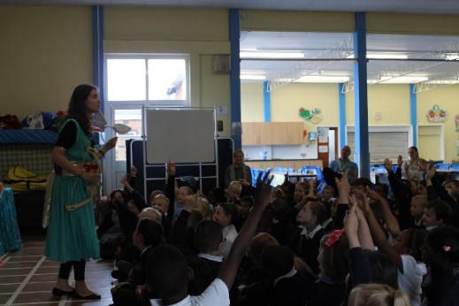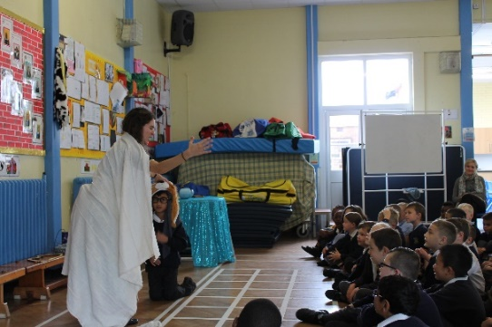
At the end of the story, the children discussed how important it is to forgive your friends, how it is better to share than to compete and the need for forgiveness if friendships are to be maintained. The children also drew out the effect of lying to your parents and not to be mean to each other.
The second story – to Year 4 and Year 5 – was Jason and the Golden Fleece, with the children taking on key roles and acting as the entire crew of the Argonauts. Anna emphasised how, in storytelling and story writing, it is important to maintain consistency with the character of the protagonist.
In the afternoon, Anna performed her own story, set in India, of Clara the Rhinoceros, involving the young children at the Nursery School as she had in Swindon.
The parents’ workshop helped parents tell their own stories, based on well-known folk tales, using Anna’s story pie segments technique to help the parents understand how stories develop and to give them permission and confidence to enact their own versions. The parents surprised themselves and the teachers with their increased confidence in storytelling through the use of props.

The total number of children directly involved with the project was 670. 4 parents attended the workshop. This number was disappointing as 30 signed up, but the weather was appalling.

Ipswich
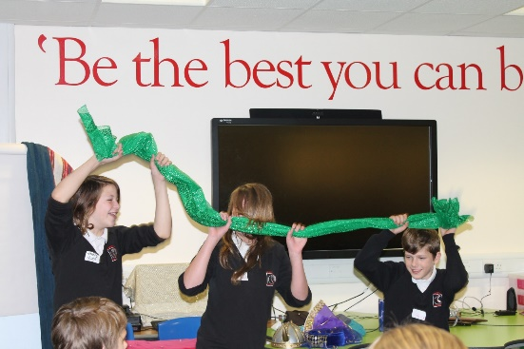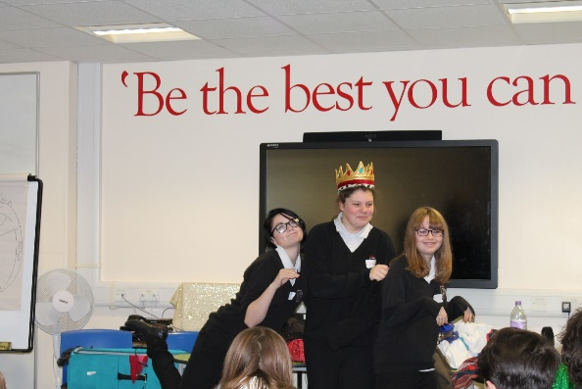
A lack of aspiration was identified in the area, with poor participation and achievement post-16. The book group identified three secondary schools who have a number of young carers who struggle with attendance, reading and writing and organised the day in partnership with the Suffolk Young Carers organisation.
The objective of the day was for the young carers to have fun, by listening to stories and learning how to tell stories themselves in workshops, creating the end of a locally-based story and performing to the rest of the group. The schools involved were Claydon High School, Claydon, Suffolk; Farlingaye High School, Woodbridge; Kesgrave High School, Ipswich.
It should be noted that the energy of the day was affected by the tragic suicide the evening before of a secondary school pupil in one of the participating schools.
The story devised by Anna linked the graves of a horse and a young man in Mound 17 at Sutton Hoo, which is local to the schools, with the medieval and European legend of the bay horse Bayard and his rider, Rinaldo. Anna performed the first element of the story, encouraging active participation of both pupils and adults, energising the students through humour and dance. She then invited the pupils to create their own endings, using the concept of story pie segments, focusing on character, aim, obstacles and final resolution, which they performed to the other students. The resulting pie-charts and pictures have been retained in the Federation archive.
The number of students directly involved was 40, with an age range of 11 – 14. It included 2 Year 10’s at Claydon who participated as part of their Leadership Skills Development Project.

Oxford
‘The school gained a great deal through access to an expert storyteller’
‘The pace kept them (the children) engaged throughout the day’

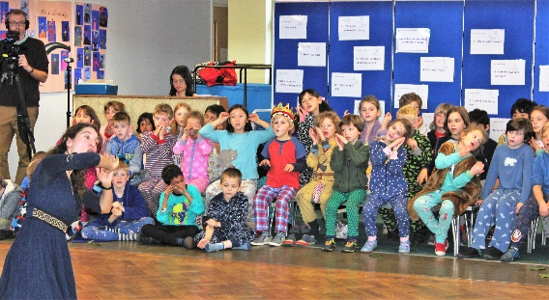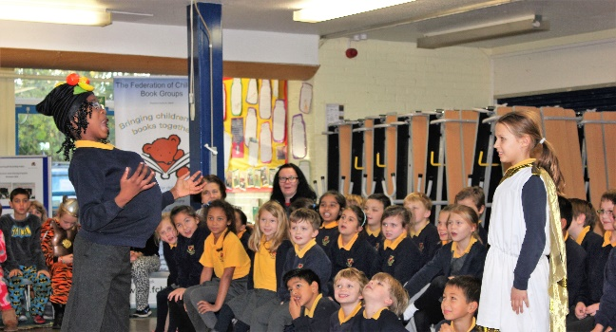
Oxford worked with three schools in deprived areas of Oxford: St. Ebbe’s, New Hinksey and St. Aloysius to create a StoryFest, which created a fitting finale to the project.
Anna worked with two year classes from each school for 2 hours each on different segments of Jason and the Golden Fleece, before bringing the three schools together at St. Ebbe’s to perform the entire story in front of an invited audience of local children and dignitaries.
The ambitious concept worked well despite Anna suffering laryngitis. The children responded well to Anna’s confidence in their ability to learn the songs and the actions required within a short space of time. The project was supported by enthusiastic teachers who assisted in the rehearsing required and in the rapid costume changes during the performance.
The complete performance has been recorded for the Federation archive and an edited version with interviews is available on YouTube.
The project was significantly enhanced through the involvement on the first day of 19 teacher training students from the Storymaking Module of the Education department at Oxford Brookes University. All the students found the day infinitely valuable in terms of understanding the role that performance storytelling can play across the curriculum and it is hoped that this partnership will help to embed the project within schools in the future.
The number of pupils involved in performing was 160 plus 19 teacher training students and an invited audience of approximately 60 adults and children.

- Evaluation and feedback from children, adults, groups and Anna Conomos
Evaluation was built into the project from the beginning, using the following criteria and measures:
Criteria | Measure
Event | Numbers of people, evaluation against target  Organisation
Inclusivity | The make-up of the ‘audience’  Out-reach beyond the group and partnerships developed
Integrity | Ensuring the best and most professional experience for all involved
Passion for making a difference and a child-centred ethos | The impact of the day on:  - The young people  - The group  - The partner organisations  - The storyteller  Assessed through feedback through questions on the day and survey after the event
Impact | Assessment of impact one month later, through conversation with the group, young people and any partnership organisations
Financial | Evaluation of final costs against budget

Method of evaluation and feedback
- Every participating school was provided with feedback forms tailored to the age range of the pupils and every pupil or class was asked to give feedback, either on the day or immediately after the event.
- The Education students at Oxford Brookes University were asked to provide evaluation on Anna’s performance and on their assessment of the value of the day for the school and for themselves as part of their Storymaking module.
- Every stakeholder was asked for their evaluation as to the success of the event and the extent to which it met their own outcomes. This was through Surveymonkey.
- Every participating group was asked through Surveymonkey as to the success of the event and whether they felt their outcomes as a group had been met.
It should be noted that, of the community stakeholders, only the EOTAS staff and Suffolk Young Carers provided feedback, which was given verbally on the day. There were no responses received from the Reading school or stakeholders.

Results
- The participating schools, children and stakeholders
(i) North Somerset (summarised by the group contact)
School:
Comments | Number of completed forms | Respondents
 | 40 | KS1 and KS2 pupils
We loved: | Anna’s imagination, her bright clothing, her expressions / smile/sparkling eyes, her energy/enthusiasm, happiness; being allowed to join in/being chosen/taking part; she was funny/mysterious/loud/mad.
What did you learn about telling stories? | to enjoy stories, to be respectful, to tell stories from other countries, that what makes a story interesting is how you tell it, to use your face/body/hands, to look at your audience, to use lots of voices, to be confident, to have fun, to enjoy it.
What was your favourite part? | Seeing the actors/audience/teachers enjoying it, watching people making things up, watching the story come alive, imagining the story, laughing when things went wrong, taking part, dressing up.
Workshop:
Comments | Number of completed forms | Respondents
 | 20 | Teachers
 | All positive
How useful did you find it? | Many found all the techniques useful and would use them to support reading/writing, for story times, to develop confidence and language skills and across the curriculum.
Any more comments | Would be very interested in another storytelling event.  Would like longer and more sessions.

(ii) Aldbourne
Swindon Great Western Hospital:
Responses | Number of completed forms | Respondents
 | 7 | All KS3 EOTAS pupils
Do you like stories | Y = 6 N = 0 Sometimes = 1
Do you read stories | Y = 4 N = 1 Sometimes = 1
Did you enjoy today? | Y = 5 N = 1 OK = 1
What did you like most? | Anna’s enthusiasm, the story (2), getting involved (3), engaging the pupils (2)
Any comments? | ‘It was fabulous’; ‘really great for taking your mind off things and doing something different’; ‘a wonderful experience’; ‘invaluable’ - The last two comments were from EOTAS staff.

Robert-le-Kyng School, Swindon:
Comments | Number of completed forms | Respondents
 | 59 | KS1 and KS2 pupils
Do you like stories | Y = 44 N = 0 Sometimes = 15
Do you read stories | Y = 41 N = 1 Sometimes = 17
Did you enjoy today? | Y = 100% N = 0
What did you like most? | The Minotaur: 20  The acting and participative nature of the day: 15  The play itself or specific elements: 15  Storytelling: 3  Anna’s enthusiasm, the story (2), getting involved (3), engaging the pupils (2)
Any comments? | Funny: 17  The show and the costumes: 8  Participation and acting: 8  The happy ending: 5  Anna is a good storyteller: 3
What could have been better? | Wanted it to be longer  Could have used more actors  Could have done a second story
Comments (verbatim) | ‘It was really fun – if you see a play about a story you get a better view of it’; ‘’we learnt about a new person called Dead Allos’; ‘we now loads more facts about Ancient Greece’; ‘really fun...almost the best day’; ‘best day ever’.  From the teachers: ‘it tied in well to the curriculum’  From the Headteacher: ‘The feedback from the children was great and the Year 5 children produced some excellent writing this afternoon as a result‘

Central@RLK, Swindon Nursery:
Comments | Number of completed forms | Respondents
 | 6 | Teachers and assistants
Do you like stories | Y = 6
Do you read stories | Y = 3 N = 2 Sometimes = 1
Did you enjoy today? | Y = 100% N = 0
What did you like most? | How Anna incorporated the children’s ideas and comments  The interaction and songs  The whole story  The sparkly princess  It was very energetic, fun and child-oriented  The giraffe
Comments (verbatim) | ‘I felt transported’; ‘it was ace’; ‘very enjoyable, fun, educational, involved all the children’

(iii) Birmingham
Combined responses from both participating schools:
Comments | Number of completed forms | Respondents
 | 29 | Children
Do you like stories | Y = 21 N = 2 Sometimes = 6
Do you read stories at home | Y = 13 N = 4 Sometimes = 12
Did you enjoy today? | Y = 28 N = 1 | Though he/she did say that they thought Anna was funny.
What did you like most? | The story: 10  Anna’s acting: 9  The slow-motion sequence: 5  Participating: 2  The costumes: 1  Athena: 1
Comments (verbatim) | ‘I liked how Anna didn’t use a book or computer, she did it by acting’; ‘best visitor to our school’; ‘we got to be part of the funniest play EVER’; ‘an awesome day’; ‘it was exciting… and funny. I couldn’t stop laughing.’ ‘it was outstanding’; ‘I don’t like assemblies but this was the best one ever’; ‘Anna was brilliant’.
Other comments | It would have been better if the children could have played Isaac and Rebecca.  I liked the free books and stickers.

Comments from the teachers
‘It was terrific how Anna involved all the children in the performance storytelling. It is a great gift… how she was able to gauge the session to make it appropriate for the age of the children. I would certainly have her come to the school again.’
‘An excellent hour…one of the best visitors to school we have had as Anna kept the children spellbound. She is a great performer and has shown a range of storytelling techniques that we can use as teachers. Very engaging and informative. REALLY LIKED HOW THE CHILDREN WERE LEFT WITH A CHALLENGE TO WRITE THEIR OWN ENDING TO A STORY.’
‘Anna was able to keep a lively bunch of children entertained and fully engaged for an hour. A great achievement! Her performance was magical and everything she did was appropriate for the age of the children. I really enjoyed the session and I think that the project to bring a storyteller into school to children that perhaps would not have seen any type of performance, a brilliant idea. I think it could certainly inspire some teachers to have a go at storytelling in this way.’
‘It was so clever how (Anna) had everyone interacting with the story. At the end of the session she gave staff and children ideas that can be built on in the classroom. Excellent how it involved various areas of the curriculum.’
‘An excellent project to bring her into schools.’
Comments from Rubery Nursery
The adults:
‘A big thank-you for choosing the school to take part in the project. Anna was brilliant, holding the children spellbound. It was lovely to see the children participating in the storytelling. They were enthralled for the whole 45 minutes.’ Headteacher.
‘I enjoyed the experience as much as the children. It was good that the adults were also encouraged to be part of the storytelling’. Assistant.
‘The children responded really well to Anna’s story. Everyone was concentrating on what was going on and although really excited still behaved extremely well for 3 and 4 year olds. A fantastic afternoon for them and the adults who were there.’ Assistant.
The children (some comments during the session)
‘I liked the story and the masks and the noises we made’.
‘I liked being a hyena and laughing’.
‘I think Anna is funny and I liked the story’.
‘The rhino was very silly in her glasses. She was nice to the animals in the end’.
‘It was funny being a lion. I can growl really loud’.
‘Can we have another story?’
Parent’s workshop:
Comments | Number of completed forms | Respondents
 | 3 | Parents
Did you enjoy today? | 100% positive
What ideas did you gain from the workshop? | How to retell a story  Lots of actions – we enjoyed taking part and doing the actions  It was fun – I found I could tell a story  Anna was great, excellent, entertaining  I enjoyed working with another Dad
How did you find the workshop? | Better than expected: 2  Met expectations: 1
Will it help you to tell stories with your children? | Definitely: 3
How could it have been better? | Have the children there as well: 2  More stories: 1
How was the organisation of the event? | 100% excellent
Comments verbatim | ‘I am glad I came…it has shown me how I can retell stories and get the children to join in.’  ‘Brilliant. I would like more of these.’  ‘I would like to do another one and try it with my kids.’  ‘Really enjoyed (it). I will try the ideas at home…I would do another workshop.’
(iv) Ipswich
Claydon High School
Comments | Number of completed forms | Respondents
 | 16 | KS3 young carers
Did you enjoy today? | Y = 16
What did you enjoy the most? | Acting: 10  Listening to and watching the story being told: 5  The humour: 2  Sharing ideas: 2  Having fun: 1
What could have been done better? | Nothing: 11  Had the whole day/made it longer: 4  Had more biscuits: 3
Would you like to create more stories? | Y: 12; N: 1; Maybe: 3
Anything else you would like to say? | More sharing of ideas: 1  Solving mysteries: 2  Make it longer: 2  Food: 1

Kesgrave High School
Comments | Number of completed forms | Respondents
 | 6 | KS3 young carers
Did you enjoy today? | Y = 6
What did you enjoy the most? | Acting out the story/the freeze frames: 3  The story: 1  It was fun and interactive: 1  Everything: 1
What could have been done better? | Nothing: 6
Would you like to create more stories? | Y: 6
Anything else you would like to say? | It was fun!  Very thrilling

- Oxford
Oxford Brookes University
Comments | Number of completed forms | Respondents
 | 19 | Education students:  Drama Teacher Training
Did you enjoy today? | 100% positive
Do you think the children enjoyed it? | 100% positive
Comments | The children were ‘very engaged’, ‘smiles’, ‘excited’, ‘focused throughout’.
What do you see as the value of storytelling? | Speaking and listening; creativity; cross-curricular; different style of learning; use of imagination; working as a group/team; engages all the children regardless of ability; immersion in stories; enjoyment; engagement; interactivity; use of drama; development of empathy and understanding; confidence and confidence in learning.
What could help in your module? | - Strategies to teach memorising through props and delivery and full audience participation  - How to present a story in a different way with audience participation  - Be very enthusiastic and more active/interactive  - Use of songs and actions and repetitions to reinforce learning  - Use lots of positive feedback, body language and facial expression
How could you use it in your future teaching? | - Use as a lesson for the Ancient Greeks  - Teach stories and encourage the use of drama  - Value of props and participation and repetition  - To enhance literacy and PSHE  - Use children’s ideas and get them to help tell stories means a child-centred approach  - Use actions in description and use active approach  - Do a week on stories and how to build knowledge  - In assembly and cross curriculum

St. Ebbe’s C.E. (Aided) Primary School
‘The children loved working with Anna because she used their ideas so creatively and made them feel confident’.
Other comments from the teachers at St. Ebbe’s are on the video.

- The participating groups
Comments | Number of completed forms | Respondents
 | 10 | At least one person replied from each group
Did you find the children engaged? | 100% very engaged
How would you rate the event? | 100% excellent
What was the organisation of the event? | 70%: excellent  20%: good  10%: satisfactory
What went well? | - Anna’s engagement of the children  - Our local group’s relationship with the schools  - The involvement of teachers in the training  - The entire event – each school felt the children benefited, need to find out about follow-up  - The logistics, the children’s engagement and participation  - The fun, the students’ interaction and participation  - It enabled collaboration between local partners and engaged with a new school and the development of local stories  - All were enthralled, the children were really enthused, able to adapt to differing abilities
What could have been better? | - Hiring a photographer at every event  - If Anna had told a complete story  - More teacher engagement  - No senior school involvement (as they dropped out)  - More time for questions at the event  - Poor parent turnout (bad weather)
What do you see as the legacy of the project?  Oxford CBG  Ipswich CBG  Reading CBG  Aldbourne CBG  North Somerset CBG | - Try to involve more schools with Anna through our next conference and through workshops etc. Sustain relationship with schools. Encourage other schools to join local group.  - I think we should show the video to all our members. I know that I have personally learnt a lot and will include much more participation when I tell stories at library events.  - Use the storytelling techniques in the classroom to feed into improving writing skills.  - Hope to hold more of this type of event for the Young Carers  - Target school would like to join our local group and get involved with Children’s Book Award testing. Also hoping to increase cooperation with other schools in that area of Reading.  - Nursery school are going to continue with the idea to develop telling stories with the props and child participation. Primary schools were going to continue the stories with different endings, develop more oral storytelling using props and pupil participation. The older children also liked the use of song in with the storytelling and will try this. An idea is being considered to organise a larger storytelling event for a wider community.  - Maybe run another session with special school?  - Storytelling session within and between year groups. Cross school sessions.
Do you think the project achieved your objectives as set out in your bid? | All said Yes – definitely, absolutely, fully...  ‘It was exciting while also being informative, encouraging (children) to develop a range of skills. Parents were involved and surprised the organisers/teachers as to how much hidden talent/ability to tell stories if encouraged and given the opportunity’.  ‘Would like to continue next year’.
Any other comments | ’Anna was inspirational and would like to think we could have more events of a similar nature.  ‘Reading CBG was thrilled to be chosen…it has helped us achieve one of our local objectives – of engaging with schools in deprived area of town.’  ‘A brilliant project that reached a wide range of children and adults in a community that suffers various forms of deprivation. All involved were extremely enthusiastic and enjoyed the experience. It would be fantastic if this project could be offered to others (groups or communities). It would be very worthwhile if similar projects can continue in future years.  ‘Very worthwhile’; ‘Thank you’; ‘Anna has worked very hard’.
Birmingham CBG:
‘Engagement and enthusiasm of all the children across the age groups when listening and participating in the stories. The stories were appropriate for each year group and the storyteller was brilliant at adapting her presentation so that it was appropriate to different ages. The length of time for each session was also spot on. Underlining themes for the stories were suitable for developing children’s social skills as well as storytelling. Anna also left each session with ideas for the children / staff to develop further. It was fantastic that the children in nursery listened extremely well and had the confidence to join in with actions or songs. It was also good for the children to see their teachers participating in activities. The parents’ workshop was also excellently planned and encouraged adults to work together to retell a well-known story. The participation of those who did attend was much better than expected. Great to see two dads attend.’

- Anna’s feedback on the project and on the Federation of Children’s Book Groups
How did you find working with the Federation?
It was wonderful working with the Federation as everyone has been responsive and always ready to help. I was impressed with how many branches the Federation has across UK and I was impressed with their team-work. The tour as well as the conference at the outset was an excellent opportunity for me to meet FCBG members. All members provided valuable support and care before, during and after the project.
The Project Coordinator:
- Made it easy for me to focus on the creative aspect of the project as she dealt efficiently and effectively with the administrative side, liaising with the schools and relevant people involved, communicating the needs of each project and following up to make sure they had been met
- Extremely well organised, quick to respond, addressed the needs of each project well ahead of time especially regarding space, sound, providing contacts for each project and travel and accommodation arrangements
- Keen to receive feedback after each event and take it on board for the next event
- Attentive and participatory at all times and in every performance
- Provided the most important details for me personally between performances ie: microphone, water, vocal breaks etc.
- Followed up on planning so that we were fully prepared for each event
- Great fun and company so the whole project was exciting and positive
- Commitment to making each project the best it could be

What did you think about the choice of projects?
They were very well chosen. A lot of variety and always looking to target as many people as possible (staff, pupils – with a variety of ages and backgrounds, parents) and to make the projects sustainable. I loved the fact that we spoke about the different options for projects with the Coordinator at the outset and she took on board ideas and input so that we could visualise this together.
What worked best?
I found all the projects rewarding and I can’t say that any one event was better than the other.
This is what worked best:
- Planning each event ahead of time
- Planning in research/writing days for events that needed specific new material
- Easy and regular access to the Coordinator to clarify details or changes in the lead up to an event.
- Because we had spread the various events out over the course of the year it was great to have regular ‘check-ins’ and updates with the Coordinator so that we could clarify the notes for each event.
- Updating the notes document for each event in advance so that I could be clear about the changes and amendments
- Timetabling the sessions so that the length and number of each were suited the way I work best. I appreciated the Coordinator taking this into account for every event
- The work that went into each event and the energy put in coupled with the books and gifts for the schools
- Emphasis on having fun!

What I enjoyed the most
I loved researching local stories and bringing communities together by bringing to life true, original, local tales with local children. I loved having the opportunity to perform these community stories with young people and their families, for example at Whitfest and to see pupils taking pride in their community, history and taking responsibility and initiative in their storytelling performances.
I love the big storytelling shows. I loved the Brunel – Deadalus story with all the pupils feeling inspired to ‘leave their mark in history’ after hearing the stories of these two great inventors - one local and one mythical - and bridging those two worlds.
I think Oxford worked extremely well, it was well planned with the three schools each taking ingredients from one story and putting together in a final performance together. It was truly festive and I love working with lots of children at once to put on a grand show for a large audience because it’s a magical experience for everyone involved. The staff INSET in North Somerset was the largest INSET I have ever conducted with staff members from four different schools and an estimated 60 or so staff members participating. This indicated how much need there is for these sorts of opportunities for members of staff to develop storytelling techniques in the work place.

What worked less well?
When teachers were not as engaged with the project - this was rare - but it was tricky in Reading, for example, when we did not feel supported by the teacher and so our hard work with the Whitley stories may not have been followed up but we hope that she was inspired and that the initiative was taken on her part to develop the storytelling work.
It was a bit difficult to find the relevant contact in Whitley in order to access local stories. However, this was an opportunity to discover the Whitfest Community Centre Facebook page with local peoples’ stories which was a gold mine! It would have been great to have had more collaboration between the school and the Whitfest Community Museum. Perhaps with more time we could create an opportunity for the pupils to perform the stories to the locals and maybe display their stories in the museum. I invited the locals to Whitfest but since they are elderly an organised visit might work better.

- Legacy and conclusions
- Legacy: what next?
Within the groups
The feedback from the participating groups above and in the Executive Summary suggests ways in which the project has already provided each group with ideas as to how to embed storytelling into local schools and with local communities.
It was important for the national Executive to feel that the whole organisation should benefit from the project. Every group has therefore received a copy of Anna’s Storytelling Teacher Training Course with two DVDs which they can use as a stand-alone resource for their member schools and as part of any storytelling events they wish to hold.
2018 marks the 50th anniversary of the official founding of the Federation of Children’s Book Groups. The Executive is currently considering making the power of oral storytelling in developing imagination one of the cornerstones of the 50th celebrations, possibly using the DVDs within our National Share-A-Story Month event as part of this focus.
Beyond the Federation
The mission of the Federation is to bring children and books together, not just within our charity but beyond. The 50th birthday offers an opportunity not only to celebrate within the charity but also to share the power of storytelling and stories with children beyond our membership, through art, music, reading and performance storytelling.
The Executive is therefore currently considering holding a national event in Birmingham which would use Anna’s storytelling and training skills as part of the celebration. This event would link the experiences of the Birmingham group during the Jean Russell Storytelling Project with the Eleanor Farjeon Children’s Literature Festival in 2013. The concept is in its early stages but would create a local focus with under-privileged schools and families, building on the success of the parent and teacher workshops, as well as a national focus on the Federation for all our groups.
We would be very excited if the Ragdoll Foundation were prepared to consider a funding bid from the Federation for such a targeted Jean Russell Storyteller event as part of our 2018 anniversary.
- Conclusions
This project would not have been successful without the selection of an excellent storyteller and the performance storyteller approach was immersive, participative and highly enjoyable for all involved.
Working with different groups and organisations with competing time commitments was a challenge that the groups met, despite issues arising, often last-minute. However, the focus of the entire project was on the benefits and enjoyment of the children and young people and the feedback received demonstrated that this objective was amply achieved.
The groups felt that their own objectives had also been achieved with the project and that they have developed firm foundations for future development of storytelling and of community and stakeholder relationships.

Anna told full stories during school assemblies and in large groups; however, she deliberately left stories half-finished at some events as part of the storytelling workshop process.
The full performance is copyrighted to Anna Conomos.
Uplands is a school for students with severe or profound learning difficulties and/or on the Autistic Spectrum Condition, all with statements of Special Educational Needs.
NED: ‘Never give up; Encourage others; Do your best’, www.thenedshow.com
Young carers are defined as ‘if you are 9 – 15 years old and care for, or are affected by, a family member who has a physical or mental illness or who has a problem with the misuse of drugs or alcohol, you are a young carer’. Suffolk young carers work with an advisor, meet other young carers at groups and activities and are supported at local schools. They are invited to talk to adults they can trust and ask for help if they need it.
Anna played these characters.

